Math 1211 Discussion Assignment 1

**The Maximum Value of a Function**

In many areas of science, engineering, and mathematics, it is useful to know the maximum value a function can obtain, even if we don’t know its exact value at a given instant. For example, if we have a function describing the strength of a roof beam, we would want to know the maximum weight the beam can support without breaking. If we have a function that describes the speed of a train, we would want to know its maximum speed before it jumps off the rails. Safe design often depends on knowing maximum values. This project describes a simple example of a function with a maximum value that depends on two-equation coefficients. We will see that maximum values can depend on several factors other than the independent variable x.

1. Consider the graph of the function y = sin x + cos x. Describe its overall shape.

* Is it periodic?
* How do you know?

The overall shape is similar to the periodic wave form like the normal since curve. 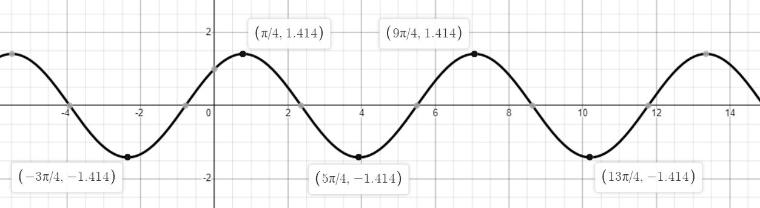

According to (*1.3 Trigonometric Functions - Calculus Volume 1 | OpenStax*, n.d.), all the trigonometric functions are **periodic functions.** The period of a function is defined to be the smallest positive value p such that existing f(x+p)=f(x) for all values x in the domain of f The sine, cosine, secant, and cosecant functions have a period of 2π.

We found from the graph f(x+2π)=f(x) for

(π/4,1.414) and (9π/4,1.414).

Thus, we conclude that y = sin x + cos x is periodic.

2. Using a graphing calculator or other graphing device, estimate the x- and y-values of the maximum point for the graph (the first such point where x > 0). It may be helpful to express the x-value as a multiple of π.

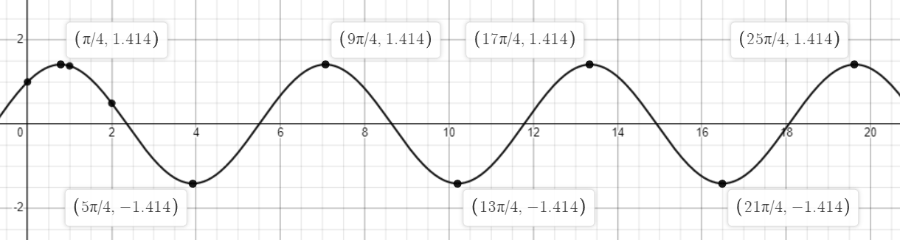

We found that maximum point is repeating at the period of 2 π

The maximum point is (π/4,1.414) and (9π/4,1.414) ..

In general equation is

3. Now consider other graphs of the form y = A sin x + B cos x for various values of A and B.

* Sketch the graph when A = 2 and B = 1, and, find the x - and y-values for the maximum point. (Remember to express the x-value as a multiple of π, if possible.)
* Has it moved?

For A=2 and B=1,

Original form is y= 2sinx +cosx

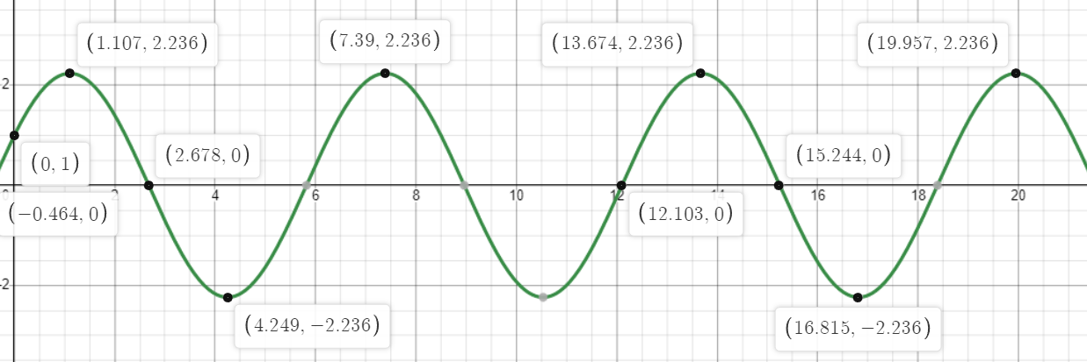

The range max is 2.2236 with and the different between each x value of the maximum point

= 7.39- 1.107

= 13.674 -7.39

It’s not has moved and its follow the same period with same range.

4. Repeat and sketch the graph for A = 1, B = 2.

* Is there any relationship to what you found in part (2)?

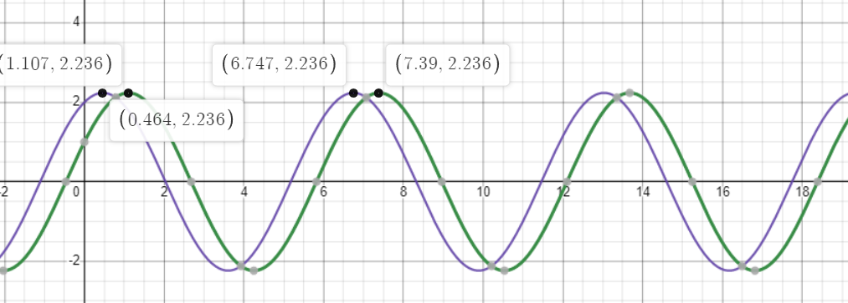

We notice that the part (2) has moved the section to the right

And they are similar as moving together as the x axis increases.

The domain and range are the same.

5. Explain what you have discovered from completing this activity using details and examples.

We found that below three functions:

Y= sinx + cosx

Y= 2sinx +cosx

Y= sinx+2cosx

The domain and range are similar. The change of coefficient of trigonometric function is not affection the period nation of the function and addition of period function is still periodic.

Reference

*1.3 Trigonometric Functions - Calculus Volume 1 | OpenStax*. (n.d.). Retrieved September 5, 2022, from https://openstax.org/books/calculus-volume-1/pages/1-3-trigonometric-functions